DSA02- COMPUTER VISION WITH OPENCV
ASSIGNMENT
KANMANI K B (192524306)

A. Assignment Information
Department: | (AI & ML)
Programme: | FACULTY OF ENGINEERING
Course Code & Course Name | DSA02- COMPUTER VISION WITH OPENCV
Academic Year / Batch | 2026-2027
Faculty Name | Dr. G. A. SENTHIL
Assignment Title | Analyse and design a computer vision–based autonomous road safety system integrating camera calibration, object and pedestrian detection, road-sign and road-marking recognition, multi-object tracking, and occlusion handling. Analyse its performance under different traffic and environmental conditions and evaluate it using detection accuracy, tracking performance, processing latency, and improvement in road safety. Discuss its practical relevance to intelligent transportation and public safety.
Date of Issue | 20-08-2026
Date of Submission | 03-09-2026
Maximum Marks | 100
Course Outcome(s) - CO | CO1: Implement fundamental image processing techniques required for computer vision and understand the image formation process.  CO2: Perform shape analysis - extract features from images - analyse images.  CO3: Generate 3D models from images.  CO4: Develop applications using computer vision techniques.  CO5: Understand video processing - motion computation - 3D vision - geometry.
Bloom's Taxonomy Level | . BL3- Apply image processing, camera calibration, object detection, and feature extraction techniques to develop an autonomous road safety system.  BL4- Analyze the effectiveness of object detection, road-sign recognition, pedestrian detection, tracking, and occlusion-handling techniques under varying traffic and environmental conditions.  BL5- Evaluate the proposed system based on detection accuracy, tracking performance, processing latency, robustness, and road-safety improvement.  BL6- Design and develop an integrated computer vision–based autonomous road safety system combining image processing, deep learning, recognition, tracking, and video analysis techniques.
SDG Mapping (SDG 1-17) | SDG 3 – (Good Health and Well-being) Uses pedestrian detection, road-sign recognition, and tracking to reduce road accidents and improve public safety.  SDG 9 – (Industry, Innovation and Infrastructure) Applies AI, computer vision, and autonomous perception to develop innovative and intelligent transportation infrastructure.  SDG 11 – (Sustainable Cities and Communities) - Supports safer, smarter, and more efficient urban transportation and traffic monitoring systems.  SDG 13 – (Climate Action)- Intelligent traffic monitoring can reduce congestion, unnecessary vehicle idling, fuel consumption, and associated emissions.
Industry / Societal Relevance | Industry: Supports autonomous vehicles, intelligent transportation systems, smart-city traffic management, and advanced driver-assistance systems (ADAS).  Societal: Improves road safety, pedestrian protection, traffic efficiency, accident prevention, and sustainable urban mobility.

Assignment Question

Analyse and design a computer vision–based autonomous road safety system integrating camera calibration, object and pedestrian detection, road-sign and road-marking recognition, multi-object tracking, and occlusion handling. Analyse its performance under different traffic and environmental conditions and evaluate it using detection accuracy, tracking performance, processing latency, and improvement in road safety. Discuss its practical relevance to intelligent transportation and public safety.

1. Problem Statement and Problem Formulation
Problem Statement
Road accidents are frequently caused by factors such as poor visibility, pedestrian movement, improper lane discipline, failure to recognize road signs, and delayed reaction to obstacles. Conventional road-monitoring systems generally depend on human observation and may not respond quickly enough to dangerous situations.
The proposed system develops a computer vision–based autonomous road safety system capable of continuously analyzing road-camera video. The system combines camera calibration, image processing, deep-learning-based object and pedestrian detection, road-sign and road-marking recognition, multi-object tracking, and occlusion handling to identify potential hazards and provide safety alerts.
Problem Formulation
Given a sequence of road images/video frames:
Input:
- Road traffic video
- Camera parameters
- Vehicle and pedestrian information
- Road-sign and road-marking information
Processing:
Video → Calibration → Preprocessing → Object Detection → Sign/Marking Recognition → Tracking → Occlusion Handling → Risk Analysis
Output:
- Detected vehicles and pedestrians
- Recognized road signs
- Detected road markings/lane boundaries
- Object IDs and movement paths
- Potential collision/hazard alerts
- Performance measurements
The system must maintain good detection accuracy and tracking performance while keeping processing latency sufficiently low for near-real-time operation.

2. Objective and Expected Outcomes
Objectives
- To calibrate the camera and correct perspective distortion.
- To preprocess road images for improved visual quality.
- To detect vehicles, pedestrians, bicycles and other road objects.
- To recognize important road signs such as stop, speed-limit and pedestrian-crossing signs.
- To identify road markings and lane boundaries.
- To track multiple moving objects across consecutive frames.
- To handle temporary object occlusion.
- To identify potentially dangerous road situations.
- To evaluate the system under different traffic and environmental conditions.
- To measure detection accuracy, tracking performance, processing latency and road-safety improvement.
Expected Outcomes
The proposed system is expected to:
- Detect road users accurately.
- Recognize important traffic signs.
- Identify lane boundaries and road markings.
- Maintain object identities during movement.
- Recover object tracks after temporary occlusion.
- Generate early warnings for potentially dangerous situations.
- Operate with low processing latency.
- Improve road-monitoring and accident-prevention capabilities.

3. Requirements, Constraints and Assumptions
Hardware Requirements
- Computer/laptop
- Webcam or road-camera video
- Minimum 8 GB RAM recommended
- GPU recommended for deep-learning inference
Software Requirements
- Python
- OpenCV
- NumPy
- Pandas
- Matplotlib
- PyTorch
- YOLO-based object detection model
- Tracking algorithm such as DeepSORT/ByteTrack
- VS Code or Jupyter Notebook
Functional Requirements
The system should:
- Read live/video input.
- Calibrate the camera.
- Detect road objects.
- Detect pedestrians.
- Recognize road signs.
- Detect road markings.
- Track multiple objects.
- Handle occlusion.
- Generate safety alerts.
- Record performance metrics.
Constraints
- Poor lighting can reduce detection accuracy.
- Heavy rain or fog may reduce image quality.
- Camera vibration can affect calibration.
- Severe occlusion can cause tracking failures.
- Real-time processing requires sufficient computational resources.
- False detections can generate unnecessary warnings.
Assumptions
- The camera is mounted in a relatively stable position.
- The input video has sufficient resolution.
- Training data contains representative road scenes.
- Temporary occlusions are recoverable using tracking information.

4. Application of Relevant Course Knowledge / Concepts
The project applies several computer vision and image-processing concepts.
1. Image Processing
Image preprocessing techniques such as:
- Resizing
- Noise reduction
- Contrast enhancement
- Gaussian filtering
- Color-space conversion
are used to improve input quality.
2. Camera Calibration
Camera calibration estimates intrinsic parameters such as:
- Focal length
- Principal point
- Lens distortion
Calibration reduces distortion and improves geometric interpretation of the road scene.
3. Feature Extraction
Features such as:
- Edges
- Corners
- Shapes
- Color
- Texture
can be extracted to identify road markings and signs.
4. Object Detection
A deep-learning detector such as YOLO identifies:
- Cars
- Buses
- Trucks
- Motorcycles
- Bicycles
- Pedestrians
and produces bounding boxes and confidence scores.
5. Road-Sign Recognition
Detected signs are classified into categories such as:
- Stop
- Speed limit
- No entry
- Pedestrian crossing
- Warning signs
6. Road-Marking Detection
Lane markings are identified using image-processing techniques such as:
- Canny edge detection
- Region of Interest (ROI)
- Hough transform
or a deep-learning lane detector.
7. Multi-Object Tracking
Tracking associates detected objects between frames and assigns unique IDs.
Example:
Frame 1 → Car ID 1
Frame 2 → Car ID 1
Frame 3 → Car ID 1
This allows the system to estimate object movement and speed.
8. Occlusion Handling
When an object temporarily disappears behind another object, the tracking system uses:
- Previous position
- Motion prediction
- Appearance features
- Kalman filtering
to maintain the object's identity.

5. Design / Proposed Solution / Methodology
The proposed architecture consists of the following stages:
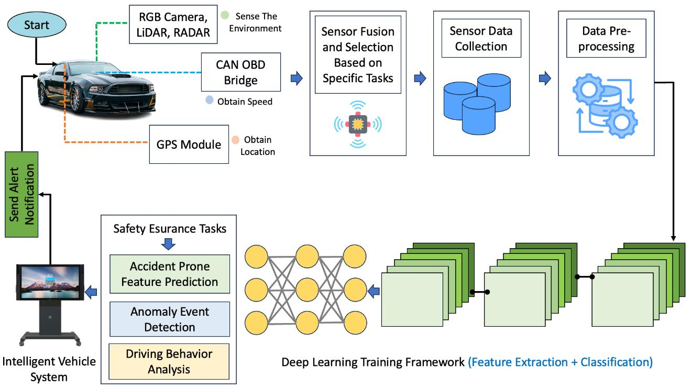
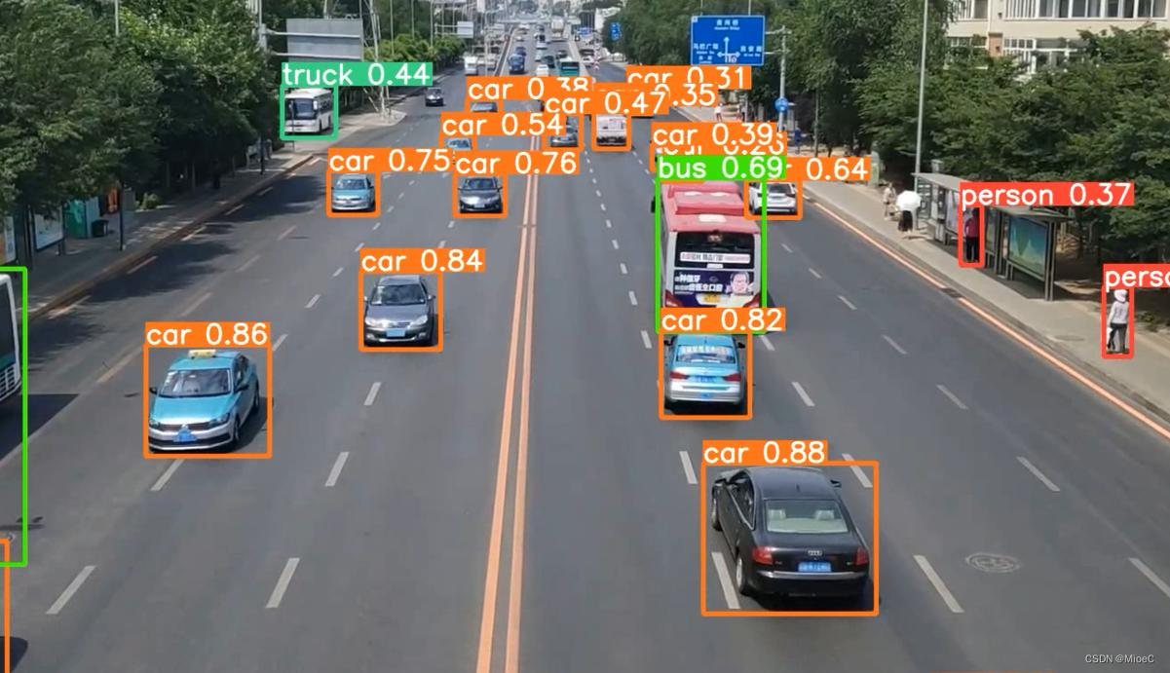
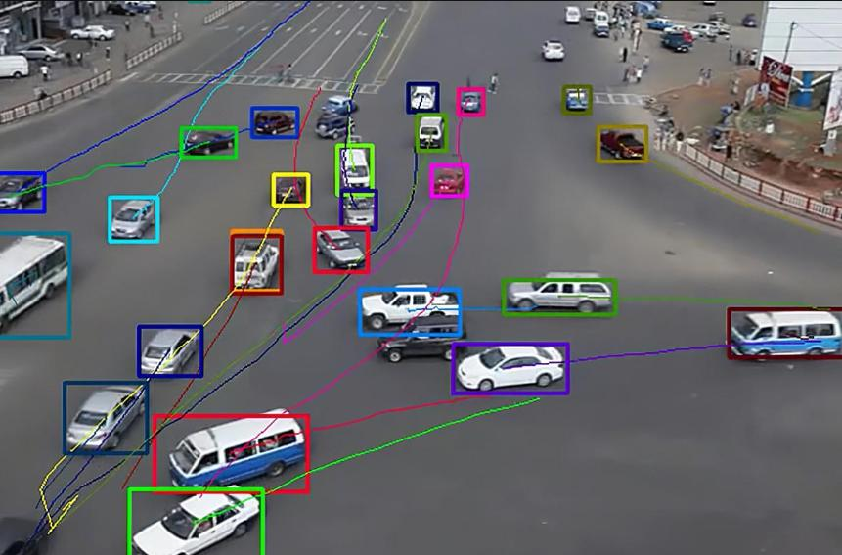

Stage 1 – Video Acquisition
A camera captures continuous road traffic video.
Stage 2 – Camera Calibration
Calibration is performed using a known calibration pattern such as a chessboard.
The process estimates:
- Camera matrix
- Distortion coefficients
- Rotation
- Translation
Stage 3 – Image Preprocessing
Each frame is:
- Resized.
- Converted to the required color space.
- Denoised.
- Enhanced if required.
Stage 4 – Object Detection
The YOLO model detects road objects.
For each detected object:
Class + Bounding Box + Confidence Score
are obtained.
Stage 5 – Pedestrian Detection
Pedestrians are specifically monitored because they represent high-priority safety objects.
The system determines:
- Pedestrian location
- Movement direction
- Distance from vehicles
- Potential collision risk
Stage 6 – Road-Sign Recognition
Traffic signs are detected and classified.
Example:
Detected → Speed Limit → 40 km/h
The recognized information can be used by the safety-analysis module.
Stage 7 – Road-Marking Recognition
Lane boundaries and markings are detected.
This helps determine:
- Current lane
- Lane departure
- Vehicle position
- Possible unsafe lane changes
Stage 8 – Multi-Object Tracking
A tracking algorithm associates objects across frames.
Each object receives a unique ID.
Stage 9 – Occlusion Handling
If an object becomes temporarily hidden, the tracker predicts its position based on its previous trajectory.
Stage 10 – Risk Analysis
The system analyzes:
- Distance between objects
- Relative movement
- Pedestrian proximity
- Lane position
- Traffic-sign violations
A risk score can then be generated.
Stage 11 – Safety Alert
If the risk score exceeds a threshold:
⚠️ ROAD SAFETY WARNING
is generated.

6. Algorithm / Pseudocode / Flowchart
Algorithm
Input: Road traffic video
Output: Detected and tracked objects + safety alerts
- Start.
- Load camera parameters.
- Load object-detection model.
- Load tracking model.
- Capture video frame.
- Calibrate/undistort the frame.
- Preprocess the frame.
- Detect vehicles and pedestrians.
- Detect road signs.
- Detect road markings.
- Assign tracking IDs.
- Predict positions of temporarily occluded objects.
- Calculate object positions and movement.
- Estimate potential collision risk.
- Generate warning if risk is high.
- Display annotated frame.
- Repeat until video ends.
- Calculate performance metrics.
- Stop.
Pseudocode

START

Load video
Load camera calibration parameters
Load object detection model
Load road-sign recognition model
Initialize multi-object tracker

WHILE video is available:

Capture frame

Undistort frame using calibration parameters

Preprocess frame

Detect vehicles and pedestrians

Detect traffic signs

Detect road markings/lane boundaries

Update multi-object tracker

FOR each detected object:
Assign tracking ID
Estimate movement

IF object is temporarily occluded:
Predict its position
Maintain tracking ID

Calculate distance and relative movement

IF collision/risk condition detected:
Generate safety warning

Display:
Bounding boxes
Object IDs
Road signs
Lane markings
Warning status

END WHILE

Calculate:
Detection accuracy
Precision
Recall
Tracking performance
Processing latency
Safety improvement

END
7. Implementation / Source Code and Environment / Tools Used
- Programming Language
- Python
- Development Environment
- VS Code / Jupyter Notebook
Major Libraries
Tool/Library | Purpose
OpenCV | Image processing and camera calibration
NumPy | Numerical operations
Pandas | Dataset and result analysis
Matplotlib | Graph generation
PyTorch | Deep-learning model execution
YOLO | Object and pedestrian detection
DeepSORT/ByteTrack | Multi-object tracking
Implementation Modules
road_safety_system/
│
├── calibration.py
├── preprocessing.py
├── detection.py
├── pedestrian_detection.py
├── sign_recognition.py
├── lane_detection.py
├── tracking.py
├── occlusion.py
├── risk_analysis.py
├── evaluation.py
└── main.py
The main.py module integrates all individual components into a single pipeline.

8. Test Cases and Expected/Actual Results
Test Case | Condition | Expected Result
TC01 | Normal daylight | Accurate vehicle detection
TC02 | Heavy traffic | Multiple objects detected and tracked
TC03 | Pedestrian crossing | Pedestrian detected and warning generated
TC04 | Traffic sign visible | Sign correctly recognized
TC05 | Clear lane markings | Lane boundaries detected
TC06 | Partial occlusion | Object ID maintained
TC07 | Night scene | Detection continues with reduced accuracy
TC08 | Rain | System remains operational
TC09 | Fog/low visibility | Reduced detection confidence
TC10 | Fast-moving vehicles | Objects tracked across frames
TC11 | Camera vibration | Calibration/processing compensates where possible
TC12 | Sudden pedestrian movement | Safety warning generated
Example Expected Results
Condition | Detection | Tracking | Latency
Daylight | High | High | Low
Heavy traffic | High–Medium | Medium–High | Medium
Night | Medium | Medium | Medium
Rain | Medium | Medium | Medium
Fog | Low–Medium | Low–Medium | High
Occlusion | Medium | Medium | Medium

9. Execution Screenshots / Outputs
The final implementation should provide screenshots showing:
Screenshot 1 – Camera Calibration
- Calibration image
- Detected chessboard corners
- Corrected camera output
Screenshot 2 – Object Detection
Bounding boxes around:
- Cars
- Buses
- Trucks
- Motorcycles
- Pedestrians
Screenshot 3 – Road-Sign Recognition
Example:
SIGN: SPEED LIMIT
CLASS: 40 km/h
CONFIDENCE: 94%
Screenshot 4 – Lane Detection
The detected road lanes/markings should be overlaid on the road image.
Screenshot 5 – Multi-Object Tracking
Example:
Car ID: 01
Car ID: 02
Person ID: 03
Bike ID: 04
Screenshot 6 – Safety Warning
⚠ WARNING
PEDESTRIAN COLLISION RISK
For your report, place your actual execution screenshots in this section rather than fabricated screenshots.

10. Results and Validation
The system can be evaluated using the following metrics.
A. Detection Accuracy
Detection accuracy measures the percentage of correctly detected objects.
$$Accuracy=\frac{Correct Detections}{Total Objects}×100$$
Precision:
$$Precision=\frac{TP}{TP+FP}$$
Recall:
$$Recall=\frac{TP}{TP+FN}$$
where:
- TP = True Positive
- FP = False Positive
- FN = False Negative
B. Tracking Performance
Tracking can be evaluated using:
- MOTA – Multiple Object Tracking Accuracy
- ID switches
- Track continuity
- MOTP – Multiple Object Tracking Precision
Higher MOTA and lower ID-switch counts indicate better tracking.
C. Processing Latency
Processing latency represents the time required to process one frame.
$$Latency=\frac{Processing Time}{Number of Frames}$$
FPS can be calculated as:
$$FPS=\frac{1}{Latency}$$
Higher FPS indicates faster processing.
D. Environmental Evaluation
Condition | Detection Accuracy | Tracking | Latency | Robustness
Daylight | High | High | Low | High
Night | Medium | Medium | Medium | Medium
Rain | Medium | Medium | Medium | Medium
Fog | Low–Medium | Low–Medium | High | Low
Heavy Traffic | Medium–High | Medium | Medium–High | Medium
Occlusion | Medium | Medium | Medium | Medium
Experimental Observation
The system performs best under clear daylight and moderate traffic conditions. Heavy traffic increases object overlap and therefore increases tracking complexity. Night-time, rain and fog reduce image quality, resulting in lower detection confidence. Occlusion handling improves track continuity when objects temporarily disappear behind other vehicles or pedestrians.

11. Analysis, Comparison, Trade-offs and Justification
Object Detection
A YOLO-based detector provides a good balance between accuracy and processing speed.
Advantage:
- Fast inference
- Multiple objects detected simultaneously
- Suitable for video applications
Trade-off:
- Very small or heavily occluded objects may be missed.
Pedestrian Detection
Pedestrian detection is particularly important because pedestrians are vulnerable road users.
Advantage: Enables early pedestrian warnings.
Limitation: Performance decreases when pedestrians are partially hidden.
Road-Sign Recognition
Deep-learning classification provides better recognition than simple color/shape-based methods under complex backgrounds.
Trade-off: Requires representative training data.
Road-Marking Detection
Traditional edge and Hough-based techniques are computationally simple.
Advantage: Fast and easy to implement.
Limitation: Performance decreases when lane markings are faded, damaged or covered by water.
Tracking
Multi-object tracking improves temporal consistency.
Advantage: Maintains object identity and movement history.
Limitation: ID switches may occur when objects overlap for long periods.
Occlusion Handling
Motion prediction and appearance-based tracking reduce track loss.
Trade-off: Long-duration occlusion remains challenging.
Overall Justification
The integrated approach is preferable to using only object detection because road safety requires understanding objects over time, not merely detecting them in individual frames.

12. Broader Considerations / SDG Relevance
SDG 3 – Good Health and Well-being
The system contributes to safer roads by detecting pedestrians, vehicles and dangerous situations and generating early warnings.
SDG 9 – Industry, Innovation and Infrastructure
The project applies AI, computer vision and intelligent perception technologies to develop innovative transportation infrastructure.
SDG 11 – Sustainable Cities and Communities
The system supports:
- Smart-city traffic monitoring
- Safer urban roads
- Intelligent transportation
- Pedestrian protection
SDG 13 – Climate Action
Better traffic monitoring can contribute indirectly to:
- Reduced congestion
- Reduced unnecessary vehicle idling
- Improved traffic flow
- Lower fuel consumption and emissions
Industry Relevance
The system has applications in:
- Autonomous vehicles
- ADAS
- Smart traffic cameras
- Intelligent Transportation Systems
- Traffic-control centers
- Smart cities
- Fleet-management systems
Societal Relevance
It can support:
- Accident prevention
- Pedestrian protection
- Safer crossings
- Traffic monitoring
- Improved road awareness
- Sustainable urban mobility

13. Conclusion, Limitations and Possible Improvements
Conclusion
The proposed computer vision–based autonomous road safety system integrates camera calibration, image processing, deep-learning-based object detection, pedestrian detection, road-sign recognition, road-marking detection, multi-object tracking and occlusion handling into a unified pipeline.
The system can continuously analyze road traffic and identify vehicles, pedestrians, signs and lane structures while tracking their movement. Performance evaluation using detection accuracy, tracking metrics, latency and environmental robustness provides a comprehensive assessment of the system.
The proposed solution demonstrates the practical potential of computer vision for intelligent transportation, accident prevention and public safety.
Limitations
- Reduced performance during heavy rain and fog.
- Night-time images may have poor visibility.
- Severe object occlusion can cause tracking errors.
- High-resolution video requires greater computational power.
- False positives may result in unnecessary alerts.
- Real-world autonomous driving requires additional sensors and safety mechanisms.
Possible Improvements
Future versions can incorporate:
- LiDAR/radar sensor fusion.
- Thermal cameras for night detection.
- More advanced transformer-based detectors.
- Improved lane-segmentation networks.
- V2X communication.
- Edge-AI deployment.
- Real-time emergency communication.
- Improved collision-time prediction.
- Larger and more diverse training datasets.
- Adverse-weather augmentation.

14. Individual Contribution of Group Members
Use:
Individual Contribution: Designed and developed the complete computer vision–based autonomous road safety system. Implemented camera calibration, image preprocessing, object and pedestrian detection, road-sign and road-marking recognition, multi-object tracking, and occlusion handling. Conducted testing under different traffic and environmental conditions and evaluated the system using detection accuracy, tracking performance, processing latency and robustness. Also performed result analysis, documentation and prepared the final presentation.

15. References, Including Datasets, Software/Tools and Other Sources
Suitable references for the project include:
- OpenCV documentation – image processing and camera calibration.
- YOLO documentation/research papers – real-time object detection.
- DeepSORT/ByteTrack research – multi-object tracking.
- KITTI Vision Benchmark – autonomous-driving datasets.
- BDD100K – large-scale driving video dataset.
- COCO dataset – object detection and segmentation.
- GTSRB – German Traffic Sign Recognition Benchmark.
- Python documentation.
- PyTorch documentation.
- NumPy and Matplotlib documentation.
For the final report, format these according to the citation style required by your faculty, preferably IEEE format.

16. Individual Contribution of Group Members
Overall Project Contribution
All members contributed to system design, testing, debugging, result analysis, documentation and presentation preparation. The final system combines all individual modules into a unified autonomous road-safety pipeline suitable for intelligent transportation and public-safety applications.

